WHEELCHAIR CONTROL THROUGH EYE- BLINKING AND IOT PLATFORM

Jeya Gokul CS1, Alagu Sriram S2, Saravana Pandi P3, M Krishnamoorthy4 Student1,2,3, Assistant Professor4, Panimalar Engineering College, India.

# Abstract

Recently, the eye-controlled wheelchair was main purpose of the disabled people. The decision making considering the eye-blinking commands to give a mobility to an eye-controlled wheelchair, is not a modest one, if we wrong decision can moving a person to wrong way, which will give additional complications instead of the solutions. In goal of the research work a microcontroller with embedded system software and IoT hardware tool used.This type of devices can handle multiple sensors as input and output as several actuators. Raspberry Platform was selected in this research work because its single board with wireless Bluetooth Low Energy and LAN on board. The implementation of these work system to discriminate an involuntary eye-controlled blinking from a low motion energy of voluntary eye-controlled blinking and take correct decision to move forward commands of a model wheelchair. The position and instructions are transfer to IoT platform to give the correct movement data to save the wheelchair.

**Keywords: -** IoT, COTS, Eye-controlled commands, Node MCU and Rehabilitation.

# INTRODUCTION

In this world millions of peoples disabled and always they need helping hands. The independent mobility techniques reduce the people dependence on caregivers. As there are several practices to control the electric wheelchair, e.g., voice recognition method, EMG signal method. There is at smallest one difficulty for each method i.e., in the instance of voice recognition and direction method it is not related for dumb persons and it is also not related in noisy parts. In this proposed work, we switch the wheelchair using intelligence sense and also with a direction control.we are executing alert system in case of alternative, control the home use while sedentary on the wheelchair itself. This work is about wheelchair that kinds disabled people life more relief, humble and independency which pay to the progress of a current civilization.

Figure 1: Block Diagram

However, some people actually feel problematic to deploy the track of wheelchair with hands because of paraplegic, old stage, handicapped. If there is a fractional disability due to any limb failure, the person sensations a certain degree of constraint to progress as per best of his or her abilities. In this case the patient is incapable to circumnavigate through the arena i.e., workroom or home, even in worst cases pointers or legs may be incompletely or entirely incapacitated. Hence,

we have made an exertion to progress a model wheelchair to overcome all those. As there are several practices to control the electric wheelchair, e.g., voice recognition method, EMG signal method. There is at smallest one difficulty for each method i.e., in the instance of voice recognition and direction method it is not related for dumb persons and it is also not related in noisy parts. In this proposed work, we switch the wheelchair using intelligence sense and also with a direction control. This switch system will drive built on measure of eye blink of the operator. In this type of regulatory mode, the operator can look around the environments easily during the direction finding to their goal point. We have also unified home computerization and alert scheme to help the persistent.

# RELATED WORKS

Several trainings had been showed for analysing the number of people in the wheelchair and the significances of placing them in a conservative wheelchair. By endorsing the self-governing mobility, it matures the feeling of self-sufficiency by reducing necessity of any subordinate. A person having any struggle in practicalmovement suffers from aloofness as they diminution their contribution from several social actions that lead to cause strain, separation and fear of carelessness. Manual forms of wheelchairs are planned in such a way that itssuggestions mobility for those entities having physical diminishing [2]. Fundamentally, for revolving the wheelchair one should apply a smallestquantity of energy to accomplish the goal. In order to decrease the physical strong point for a weak patient many academics have used knowledges to progress power wheelchairs. Our development is planned in a dissimilar way such as promising safety travel, we are executing alert system in case of alternative, control the home use while sedentary on the wheelchair itself. This work is about wheelchair that kinds disabled people life more relief, humble and independency which pay to the progress of a currentcivilization.

The very first method to solve the stated problem was obtainable in 2014 as a print in the international workshop on Wearable Robotics (WeRob) in Baiona, Spain, exactly the subsequent devices were used: Arduino and Bluetooth statement board, Mind Wave mobile 2 EEG receiver from NeuroSkyworker. MindWavereceiver can deliver EEG signs from attention, consideration, but the foremost problem here was to be able to obtainasuitableattention EEG signals to give the compulsory commands. EEG stands for Electroencephalography; EEG is an electrophysiological monitoring technique to best electrical movement of the brain. It is characteristically non-invasive, with the conductorslocated along the scalp.

In 2017, also in a WeRob conference a second approach was presented but this time a first attempt with blinking instructions was presented. we are executing alert system in case of alternative, control the home use while sedentary on the wheelchair itself. This work is about wheelchair that kinds disabled people life more relief, humble and independency which pay to the progress of a current civilization.

# PROPOSED METHOD

The goal of the work the manufacturing design process was trailed which as first one comprises the description of a clear problematic report, then relevant evidence was collected in command to produce multiple explanations. As fourth part, the data was analysed, an explanation was designated and to finish, the proposed explanation was tested and realized.

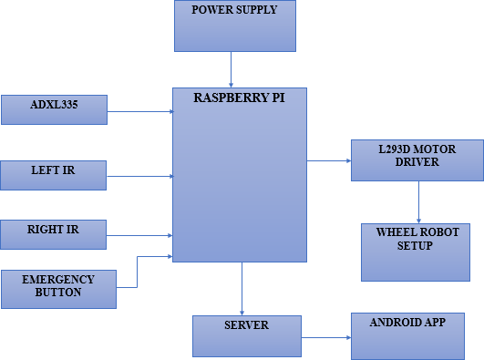

Figure 2: Proposed Method

## Geared Motor

A geared motor is used to produce in height rotation enough to carry weight. This is realized by an integrated sequence of gears or a gearbox, which is being devoted to the foremost rotor and the shaft through a second saving shaft. This is then associated to a sequence of gears or gearbox to generate a series of decrease gears.

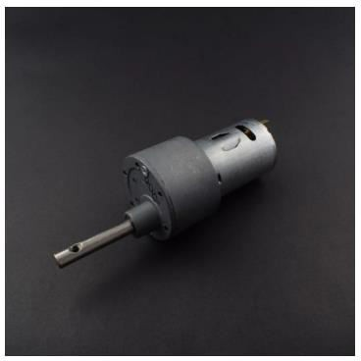

Figure 3: DC Motor

## Motor Driver L298N

Motor drivers’performances as an edge between motors and switch circuits. Switch circuitry the whole thing on low Present whereas motor needs high current so it is the purpose of the motor driver to change the low Current switch signals into high current signal. The L298N motor driver which is a low current driver is hand-me- down. L298N board is a twin motor driver

which assistance to edge motors which draw up to 2A of present.

## Brain Wisdom

The brain wisdom safely procedures and outputs the EEG power bands (alpha waves, beta waves, etc), esense pulses (attention and meditation) and eye winks. The device consists of a earpiece, an ear- clip, and a sensor arm. The headband situation and ground conductors are on the ear clip and the EEG electrode is on the device arm, resting on the forehead above the eye. It usages a single AAA battery- operated with 8 hours of battery-operated life.

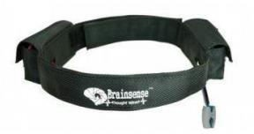

Figure 4: Brain Wisdom

* 1. ***MCU Node***

MCU node is a low-cost open source IoT stand. It originates with ESP8266 WiFiUnit which is a self-contained SOC with shared TCP/IP protocol stack that can give any microcontroller access to your WiFi network. It interconnects over MQTT protocol, which is extensively used in IoT (Internet of Things) embedded requests, where each sensor is linked to a server and we have access to switch them over the internet.

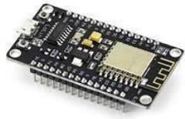

Figure 5: MCU Node

## TFT Display

TFT stands for Thin Film Transistor. TFT is Liquid Crystal Display is a thin demonstration type, where a junction transistorfixed into each crystal gate; these junction transistors are then printed on thintransparent film. The knowledge was designed to recover image potentials, such as difference and addressability.

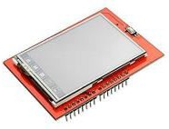

Figure 6: Thin Film Transistor

## Interface Control

A touchscreen is used as the control boundary. The user can hand-pick mode of switch. The wheel chair is measured either using eyeblink or by joystick. GUI is very user approachable. It has also establishment for choosing various procedures like home mechanization, and alert passageway. The battery level is designated on the screen when the battery icon is pushed.



Figure 7: Thin Film Transistor

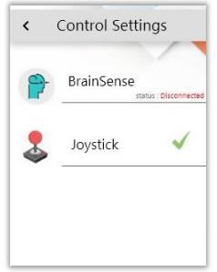

Figure 7: Selection Mode Switch

## Brainwaves

In Brain computer edge, it serves as an effective assistive knowledge that can help incapacitated people in their routine life expectancy. we are executing alert system in case of alternative, control the home use while sedentary on the wheelchair [4] itself. This work is about wheelchair that kinds disabled people life more relief, humble and independency which pay to the progress of a current civilization. Brain sensor senses whether the eye is exposed or closed. For every indication there will be separateactivities.

# EXPERIMENTAL RESULT

It is acompleteoperation of the plannedcomputer hardware system. We have effectivelyintended and made anoriginal of the planned design. The figure.8 shows the forward-facing and side view of the wheel chair we realized.

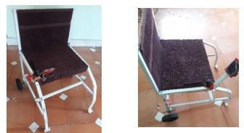

Figure 8: Prototype

we are executing alert system in case of alternative, control the home use while sedentary on the wheelchair itself. This work

is about wheelchair that kinds disabled people life more relief, humble and independency which pay to the progress of a current civilization.

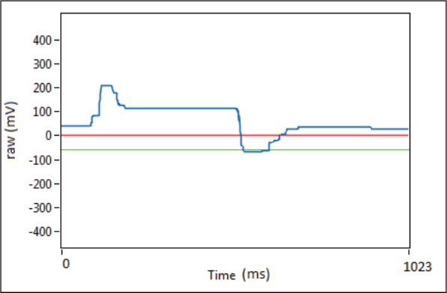

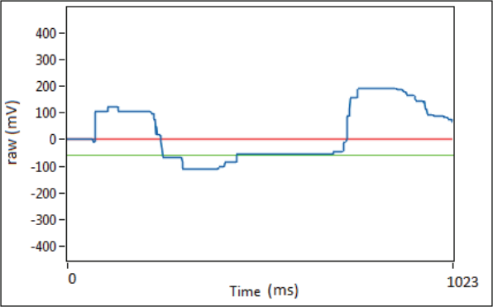

Figure 9: Statistical median method

The expedient was able to perform the desired purposes and activities with zero error proportion in its intentions and statement between each scheme. The consequencespropose that this prototype has a promising future once applied with a real wheelchair.The prototype expedient is fully useful and can be measured locally or remotely using the IoT dashboard. The given instructions of movement work rendering all settings strictures. Future work on this scheme would include the addition and test of addedindividuals in instruction to be able to sensedissimilar level of slow voluntary blinking instructions.

# CONCLUSION

The goal of these research work to detect a system to slow voluntary eye blinking was analysed and tested. Its 100% possible reliability of the measurement of the position

and movement of a wheelchair like simulation process. The internet of things and raspberry platform was very successful platform of the IoT and Rsapberry.we are executing alert system in case of alternative, control the home use while sedentary on the wheelchair itself. This work is about wheelchair that kinds disabled people life more relief, humble and independency which pay to the progress of a current civilization.The implementation of these work system to discriminate an involuntary eye-controlled blinking from a low motion energy of voluntary eye-controlled blinking and take correct decision to move forward commands of a model wheelchair.

# REFERENCES

1. N. de Estad´ıstica y Censo, “Encuestanacionalsobrediscapacidad 2018,” May 2019. [Online]. Available: [https://http://inec.cr/sites/default/files/documet](https://http/inec.cr/sites/default/files/documetos-bibliotecavirtual/reenadis2018.pdf) [os-bibliotecavirtual/reenadis2018.pdf](https://http/inec.cr/sites/default/files/documetos-bibliotecavirtual/reenadis2018.pdf)
2. S. Shinde, S. Kumar, and P. Johri, “A review: Eye tracking interface with embedded system iot,” in 2018 International Conference on Computing, Power and Communication Technologies (GUCON), Sep. 2018, pp. 791– 795.
3. U. Garg, K. K. Ghanshala, R. C. Joshi, and R. Chauhan, “Design and implementation of smart wheelchair for quadriplegia patients using iot,” in 2018 First International Conference on Secure Cyber Computing and Communication (ICSCCC), Dec 2018, pp. 106–110.
4. Carrasquilla-Batista, K. Quiros-Espinoza, and

C. G ´ omez-Carrasquilla, ´ “An internet of things (iot) application to control a wheelchair through eeg signal processing,” in 2017 International Symposium on Wearable Robotics and Rehabilitation (WeRob), Nov 2017, pp. 1–1.

1. S. Khandani, “Engineering design process, education transfer plan,” 2005. [Online]. Available: [https://www.dphu.org/uploads/attachements/b](https://www.dphu.org/uploads/attachements/books/books25470.pdf) [ooks/books25470.pdf](https://www.dphu.org/uploads/attachements/books/books25470.pdf)
2. M. Varela, “Raw eeg signal processing for bci control based on voluntary eye blinks,” in 2015 IEEE Thirty Fifth Central American and

Panama Convention (CONCAPAN XXXV), Nov 2015, pp. 1–6.

1. Automatic Camera Based Eye Controlled Wheelchair System Using Raspberry Pi - International Journal of Science, Engineering and Technology Research (IJSETR), Volume 5 Issue 1, January 2016.
2. Speed Control of Brushless DC Motor: A Comparative Study ,2012 IEEE International Conference on Power Electronics, Drives and Energy Systems December16- 19, 2012, Bengaluru, India.
3. Dey, S., Roy, A., & Das, S. (2016). Home automation using Internet of Thing. 2016 IEEE 7th Annual Ubiquitous Computing, Electronics & Mobile Communication Conference (UEMCON). doi:10.1109/uemcon.2016.7777826
4. Asadullah, M., & Raza, A. (2016). An overview of home automation systems. 2016 2nd International Conference on Robotics and Artificial Intelligence (ICRAI). doi:10.1109/icrai.2016.7791223
5. Eye Movement Controlled Wheel Chair for Physically Disabled People, International Journal of Innovative Research in Computer and Communication Engineering An ISO 3297: 2007 Certified Organization Vol.5, Special Issue 4, June 2017.
6. Smart wheelchair based on eye tracking, 2016 9th Biomedical Engineering International Conference (BMEiCON) , 7-9 Dec. 2016.
7. Patient Monitoring Smart Wheelchair, International Journal of Electrical, Electronics and Data Communication, ISSN: 2320-2084 Volume-3, Issue-6, June-2015.
8. Powered wheelchair controlled by eye- tracking system, Optica Applicata ,Vol. XXXVI, No. 2-3, 2006.